**Modul transaksi “Jadwal Kuliah & Jadwal Ujian”**

Programmer : Darmawan  
Tanggal Perkerjaan : 17-10-2012

1. Menu 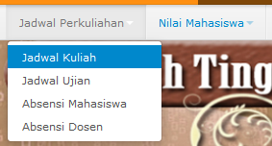
2. Jadwal Kuliah

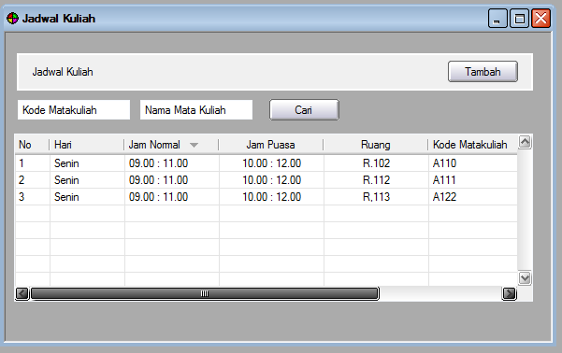

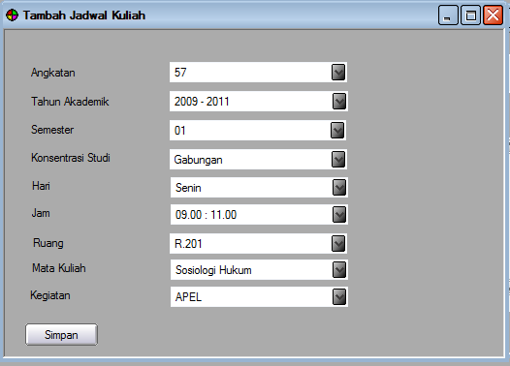

Tabel :

|  |  |  |
| --- | --- | --- |
| m_angkatan | m_tahun_akademik | m_semester |
| m_ruang | m_hari | m_ paket_mata_kuliah |
| t_dosen_ajar | t_jadwal_kuliah |  |

1. Jadwal Ujian

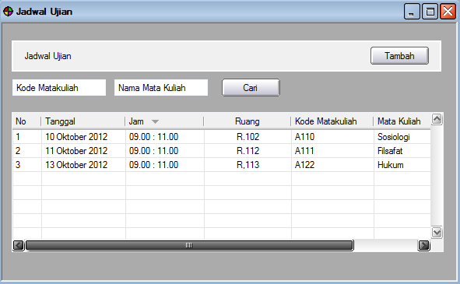

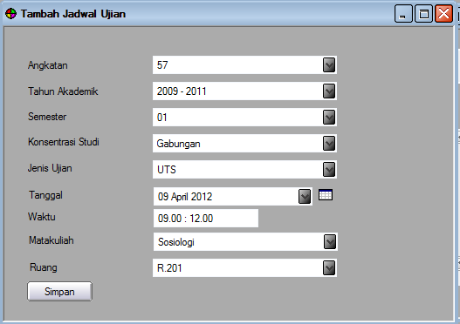

Database :

|  |  |  |
| --- | --- | --- |
| m_angkatan | m_tahun_akademik | m_semester |
| m_ruang | m_hari | m_ paket_mata_kuliah |
| t_jadwal_ujian |  |  |